|  |  |  |  |  |
| --- | --- | --- | --- | --- |
| **NAME** | **EMAIL** | **NATIONALITY** | **COUNTRY OF RESIDENCE** | **E-SIGN** |
| Aryan Tiwari | [aryan.2125cs1071@kiet.edu](mailto:aryan.2125cs1071@kiet.edu) | INDIAN | INDIAN |  |
| Saket Tiwari | [saket.2125csit1023@kiet.edu](mailto:saket.2125csit1023@kiet.edu) | INDIAN | INDIAN |  |
| Sakshi Gupta | [sakshi.2125cs1013@kiet.edu](mailto:sakshi.2125cs1013@kiet.edu) | INDIAN | INDIAN |  |
| Ashutosh Giri | [ashutosh.2125cs1054@kiet.edu](mailto:ashutosh.2125cs1054@kiet.edu) | INDIAN | INDIAN |  |
| Akash Goel | [akash.goel@kiet.edu](mailto:akash.goel@kiet.edu) | INDIAN | INDIAN |  |

**Development and Implementation of an Integrated Web-Based Office Document Management System**

**Proposed Title:**

Development and Implementation of an Integrated Web-Based Office Document Management System

**Field of invention**:

This invention relates to the field of office management technology, specifically to the development and implementation of a web-based system for managing, storing, and retrieving office documents in an integrated manner.

**Background:**

Office document management is crucial for businesses of all sizes, ensuring that documents are stored securely, are easily accessible, and can be retrieved quickly when needed. Traditional document management methods are often manual, leading to inefficiencies, potential data loss, and security vulnerabilities. With the advent of digital technology, there is a growing need for a web-based system that can integrate various document management functions into a single platform, offering a streamlined approach to document handling.

**Objectives:**

* **Develop a centralized web-based platform** for managing office documents that is accessible from any internet-enabled device.
* **Integrate document storage, retrieval, and sharing functionalities** within a single system to enhance efficiency.
* **Implement robust security measures** to protect sensitive office documents from unauthorized access.
* **Provide user-friendly interfaces** that allow both technical and non-technical users to manage documents with ease.
* **Enable seamless collaboration among team members,** allowing real-time document editing and sharing.

**Flow Chart:**

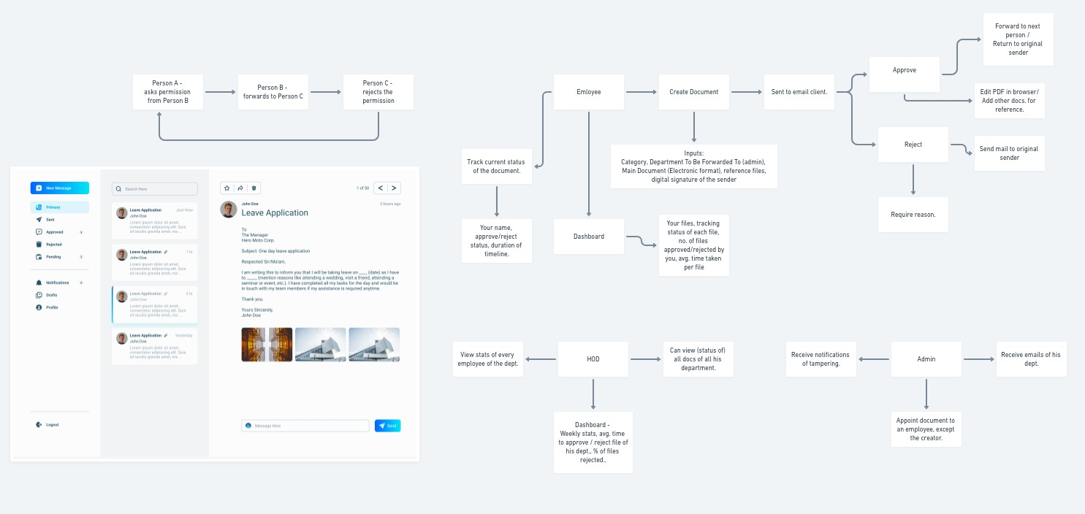





**Claims:**

* A web-based office document management system that provides centralized storage, retrieval, and sharing of office documents.
* The system allows users to access and manage documents through a secure login interface, ensuring only authorized users can handle sensitive information.
* A feature of the system includes real-time collaboration tools, enabling multiple users to edit and comment on documents simultaneously.
* The system integrates with existing office software, allowing for seamless document import and export.
* The document management system offers automated version control, ensuring that document history is maintained and previous versions can be accessed when needed.

**Technology used:**

* **Software:**
* **Web development frameworks** (e.g., Django, Spring) for the backend implementation.
* **Frontend technologies** (e.g., React, Angular) for creating user-friendly interfaces.
* **Database systems** (e.g., MySQL, MongoDB) for secure and scalable document storage.
* **APIs** for integration with third-party office software (e.g., Google Drive, Microsoft Office).
* **Hardware:**
* **Servers** to host the web-based system.
* **Computers and mobile devices** for end-user interaction with the system.

**Proposed Methodology:**

* **Document Upload:** Users can upload documents via the web interface in various formats (PDF, DOCX, etc.).
* **Document Organization:** Uploaded documents are automatically categorized based on metadata and user-defined tags.
* **Search and Retrieval:** Users can perform keyword searches to retrieve documents, with advanced filtering options available.
* **Security:** Implement multi-factor authentication and encryption to protect documents from unauthorized access.
* **Collaboration:** Users can share documents with team members, set permissions, and collaborate in real-time.
* **Version Control:** The system automatically tracks document changes and maintains a history of all versions.

**Authentication:**

The system employs a multi-layered authentication process, requiring users to verify their identity through credentials like usernames and passwords. Additional security measures, such as biometric authentication or authentication apps, can be implemented based on the organization’s security requirements.

**User Modules:**

* Administrator Module: Allows the admin to manage user permissions, document categories, and system settings.
* Employee Module: Enables employees to upload, retrieve, and collaborate on documents.
* Manager Module: Provides managers with oversight of document workflows and approval processes.

**End Users:**

* Corporate offices looking for a streamlined document management solution.
* Small and medium-sized businesses aiming to improve document handling efficiency.
* Organizations requiring high-security document management, such as law firms and financial institutions.

**Advantages:**

* Centralized and efficient document management, reducing time spent searching for documents.
* Enhanced security measures to protect sensitive information.
* Improved collaboration and workflow, allowing teams to work together seamlessly.
* Reduced risk of document loss, with automated backups and version control.

**Conclusion:**

The development and implementation of an integrated web-based office document management system offer a significant advancement in office technology. By centralizing document management, enhancing security, and improving collaboration, this system addresses the challenges faced by modern offices, leading to increased efficiency and better document handling practices.